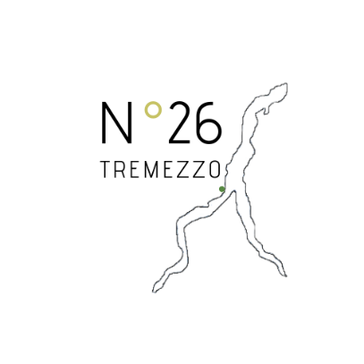 

**Menù Pasqua 2024**

**AMUSE BOUCHE**

**Small quiche of leeks, potatoes & sour cream**

**STARTERS**

**Easter egg cooked at low temperature, cauliflower velouté, chive oil and pan brioches chips**

**FIRST COURSE**

**White turnip risotto,roast guinea fowl breast and its juice**

**FISH MAIN COURSE**

**Grilled char escalope, smoked potatoes with foie grass fondant**

**MEAT MAIN COURSE**

**Traditional easter roasted goat on soft polenta bed with sweet and sour vegetables**

**DESSERT**

**Twice-chocolate mousse, strawberry osmosis, citrus brittle and shiso**

**Homemade Italian Colomba Easter cake**

***Price 58€ per person, drinks not included***